when we define individual lines for our selection screen, we need to define the start and end of each line. And in between the start and end, we include the specific parameters and select option statements.

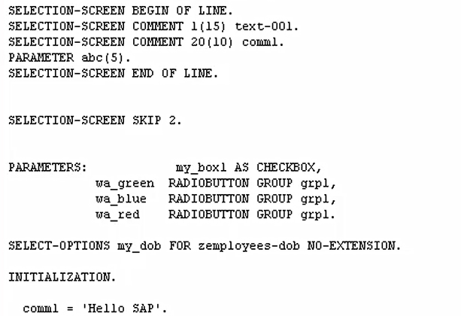

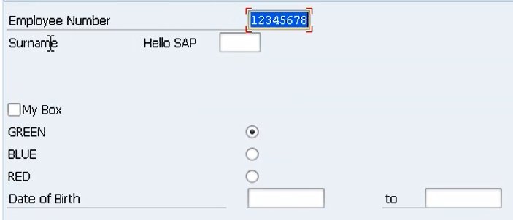

Let's go back to the screen. See here we defined the parameter field but see how it didn't automatically get assigned a comment or description that refers to the technical name of the field.

Well, that's because we used specific comments on the line. So whenever you use the BEGIN OF LINE and END OF LINE to define the line on the screen, the selection text itself that describes the element is not displayed. And that's when you would use the comments to create your own description on the line.

Now one more addition, this can only be used when you are at the BEGIN OF LINE and END OF LINE, is the position addition. But we do have the option of specifying the position of the next element separately.

So, we would do SELECTION-SCREEN. And then we would include position, and then we can specify the position using an integer. So, we could say position 35.

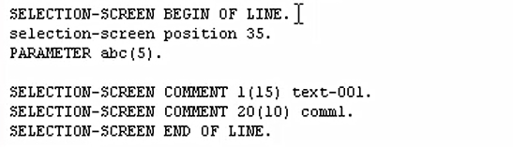

if we include a parameter straight after this position, then our parameter will appear in position

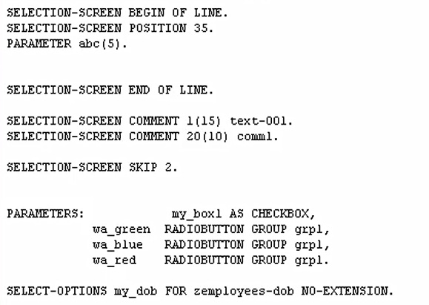

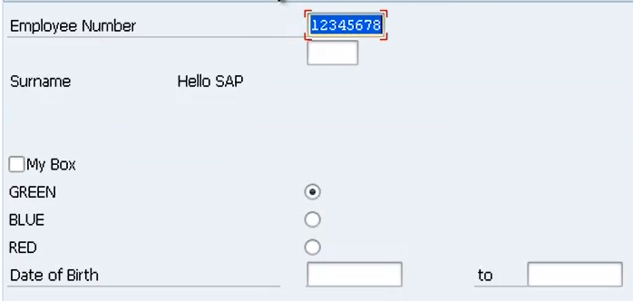

Now we do have something else to add on to the position. And that is we have some I guess you call them constants that we can use.

So, by default we'll go back to the screen. We can see we have a default position here, and we have a default position here. Well, this is referred to as position low, and this is position high.

